Website Description
Chewx is a vibrant, fun-filled online store dedicated to selling delicious, Halal-certified gummi candies that are made with natural flavours, real fruit juices, and packaged in eco-conscious materials. Designed to spread joy and flavour in every bite, the website blends bold visuals, playful branding, and easy navigation to create a candy-shopping experience that's exciting and meaningful. Chewx is aimed at fun-loving, socially aware individuals and families who care about quality ingredients, community impact, and the environment—without compromising on taste or fun.

Target Audience Personas
Persona 1: Sara Borg
- Name: Sara Borg
- Age: 28
- Occupation: Primary School Teacher
- Location: Birkirkara
- Lifestyle: Amina lives a healthy, mindful lifestyle and follows a Halal diet. She loves fun treats but is selective about what she consumes and shares with her students and young relatives. She cares deeply about sustainability and supports brands that give back to the community.
- Goals & Needs: She wants a fun, trustworthy candy brand that aligns with her dietary needs and values. Chewx’s Halal certification, community donations, and eco-packaging make it an ideal choice.
- How She Uses the Site: Shops for classroom treats, birthday party favours, and personal snacks, while checking for ingredient info and impact stories.

Persona 2: Tyler Xuereb
- Name: Tyler Xuereb
- Age: 19
- Occupation: University Student / TikTok Creator
- Location: Qawra
- Lifestyle: Tyler’s all about vibrant aesthetics, unique products, and sharing cool finds online. He enjoys snacks that are bold and Insta-worthy, and he likes supporting ethical, feel-good brands.
- Goals & Needs: Tyler wants fun, photogenic candy with bold flavour and a brand that feels fresh and ethical. He’s also drawn to playful mascots and clever social media campaigns.
- How He Uses the Site: Browses for limited edition flavours, explores mascot stories, and shares unboxing videos with his followers.

Web Accessibility Overview
The Chewx website is designed with accessibility in mind, ensuring that everyone—including users with disabilities—can enjoy a smooth and inclusive experience. Key accessibility features include:
- Readable Typography: Bold, high-contrast fonts with sufficient sizing for easy reading.
- Alt Text for Images: All product and visual elements include descriptive alt tags for screen readers.
- Keyboard Navigation: Users can navigate the site fully via keyboard without needing a mouse.
- Colour Contrast: Bright, vibrant colours are carefully balanced with appropriate contrast to accommodate users with visual impairments or colour blindness.
- Responsive Design: The site adapts seamlessly to various devices and screen sizes, supporting both mobile and desktop users.
- Clear CTAs: Buttons and links are clearly labelled with action-based text, reducing confusion and enhancing usability.

Low Fidelity – 1
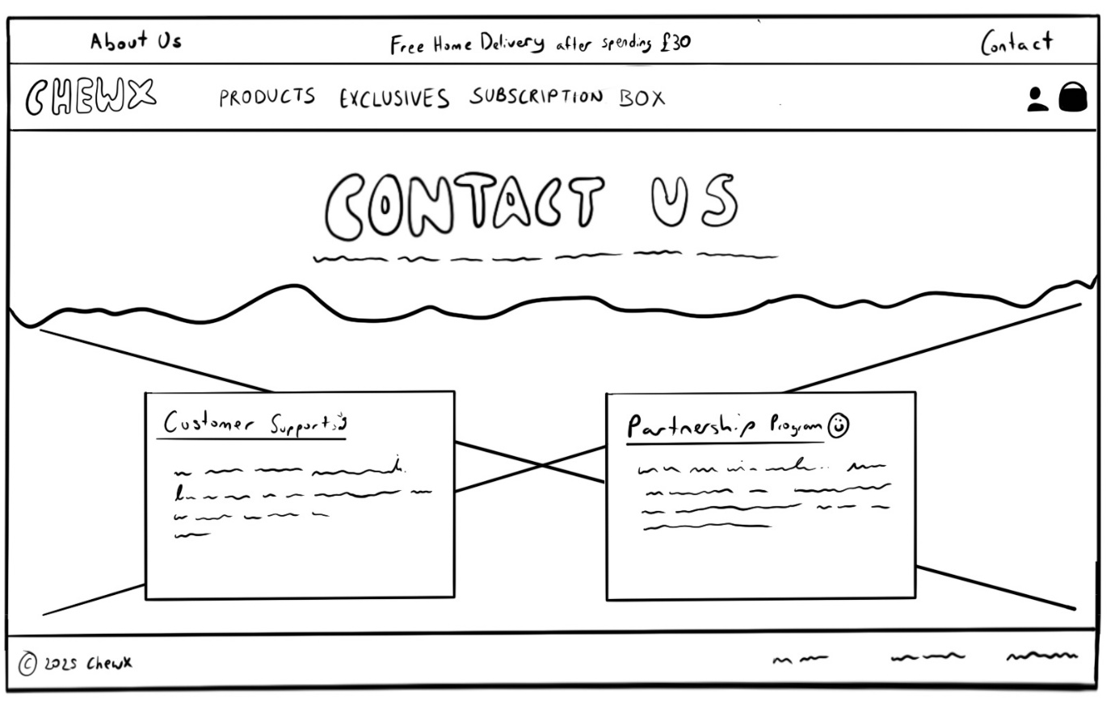
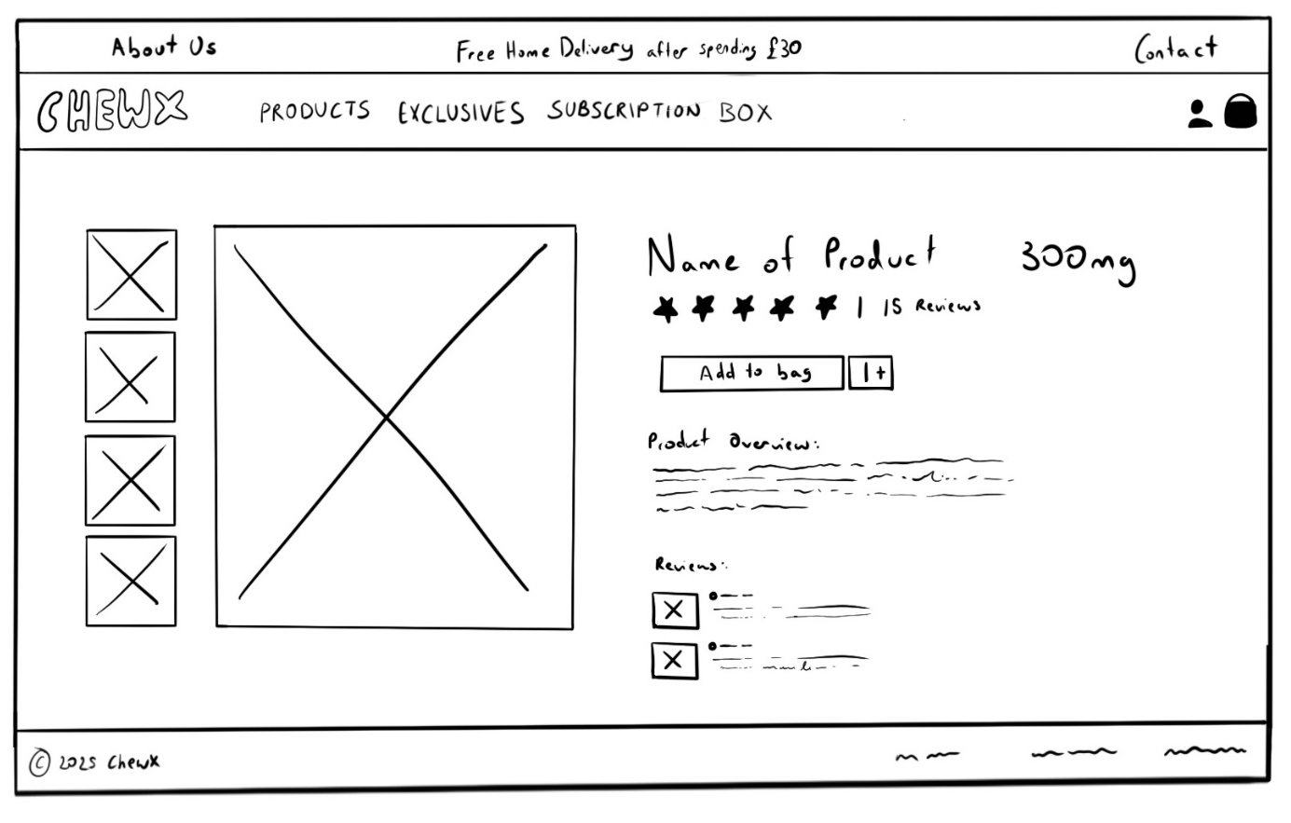
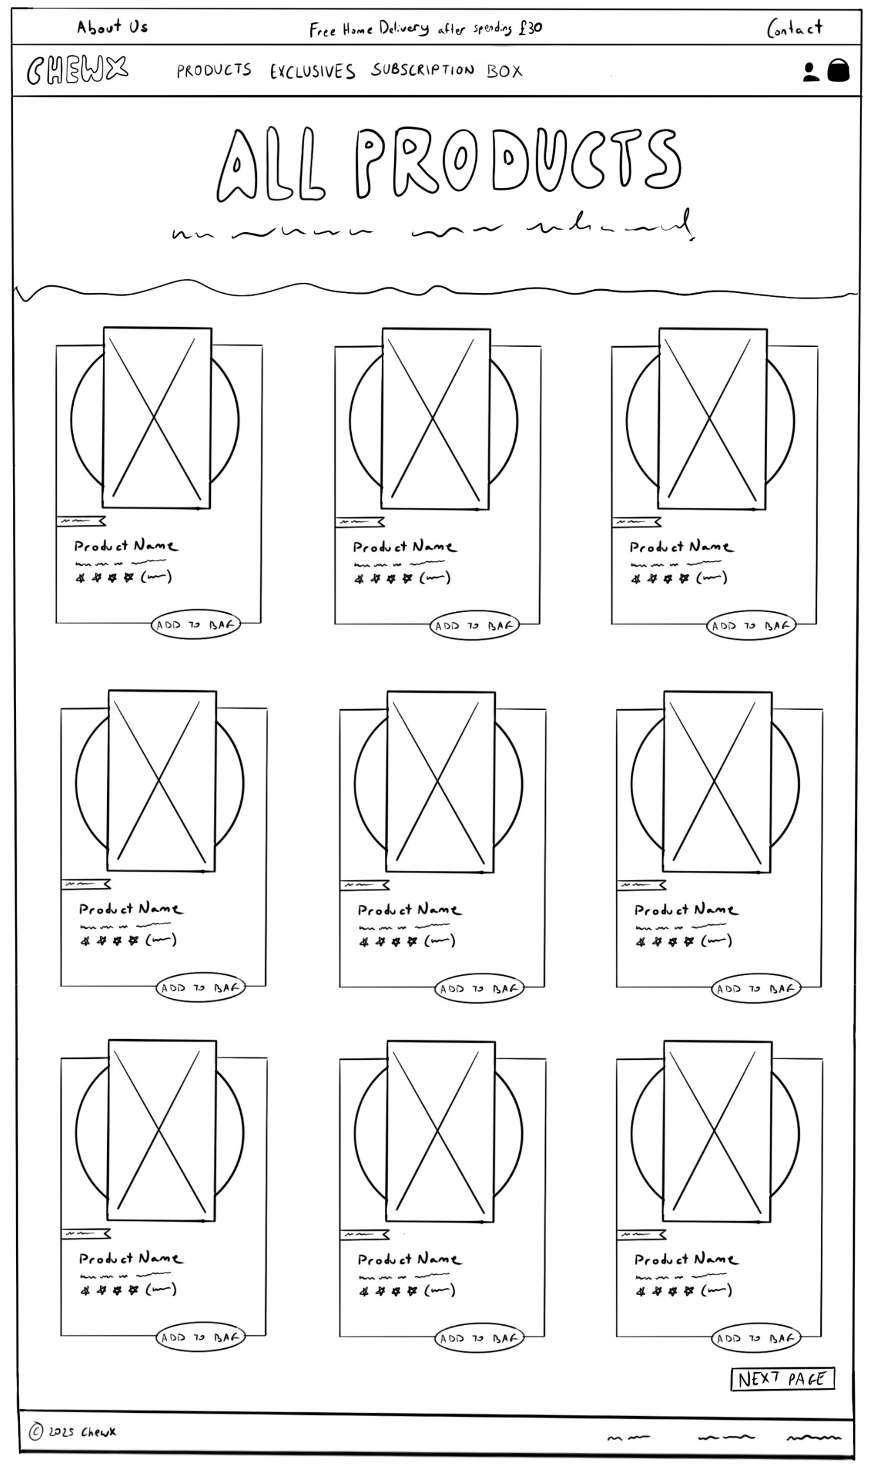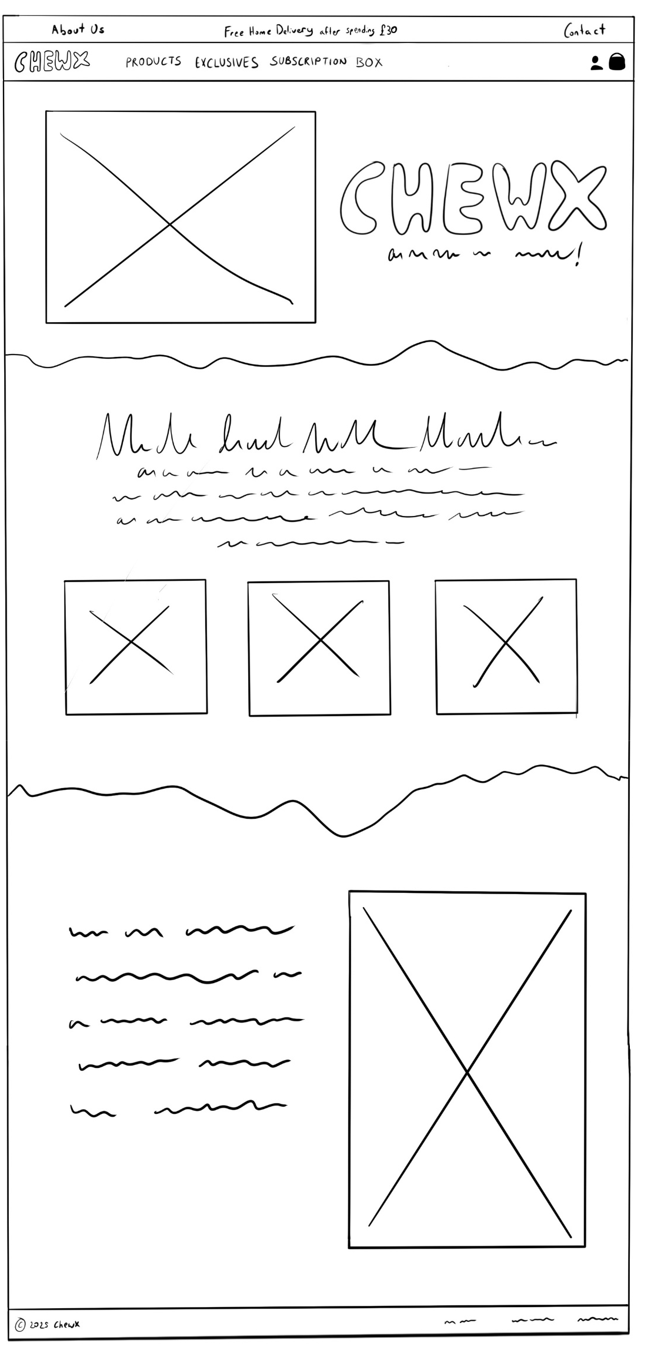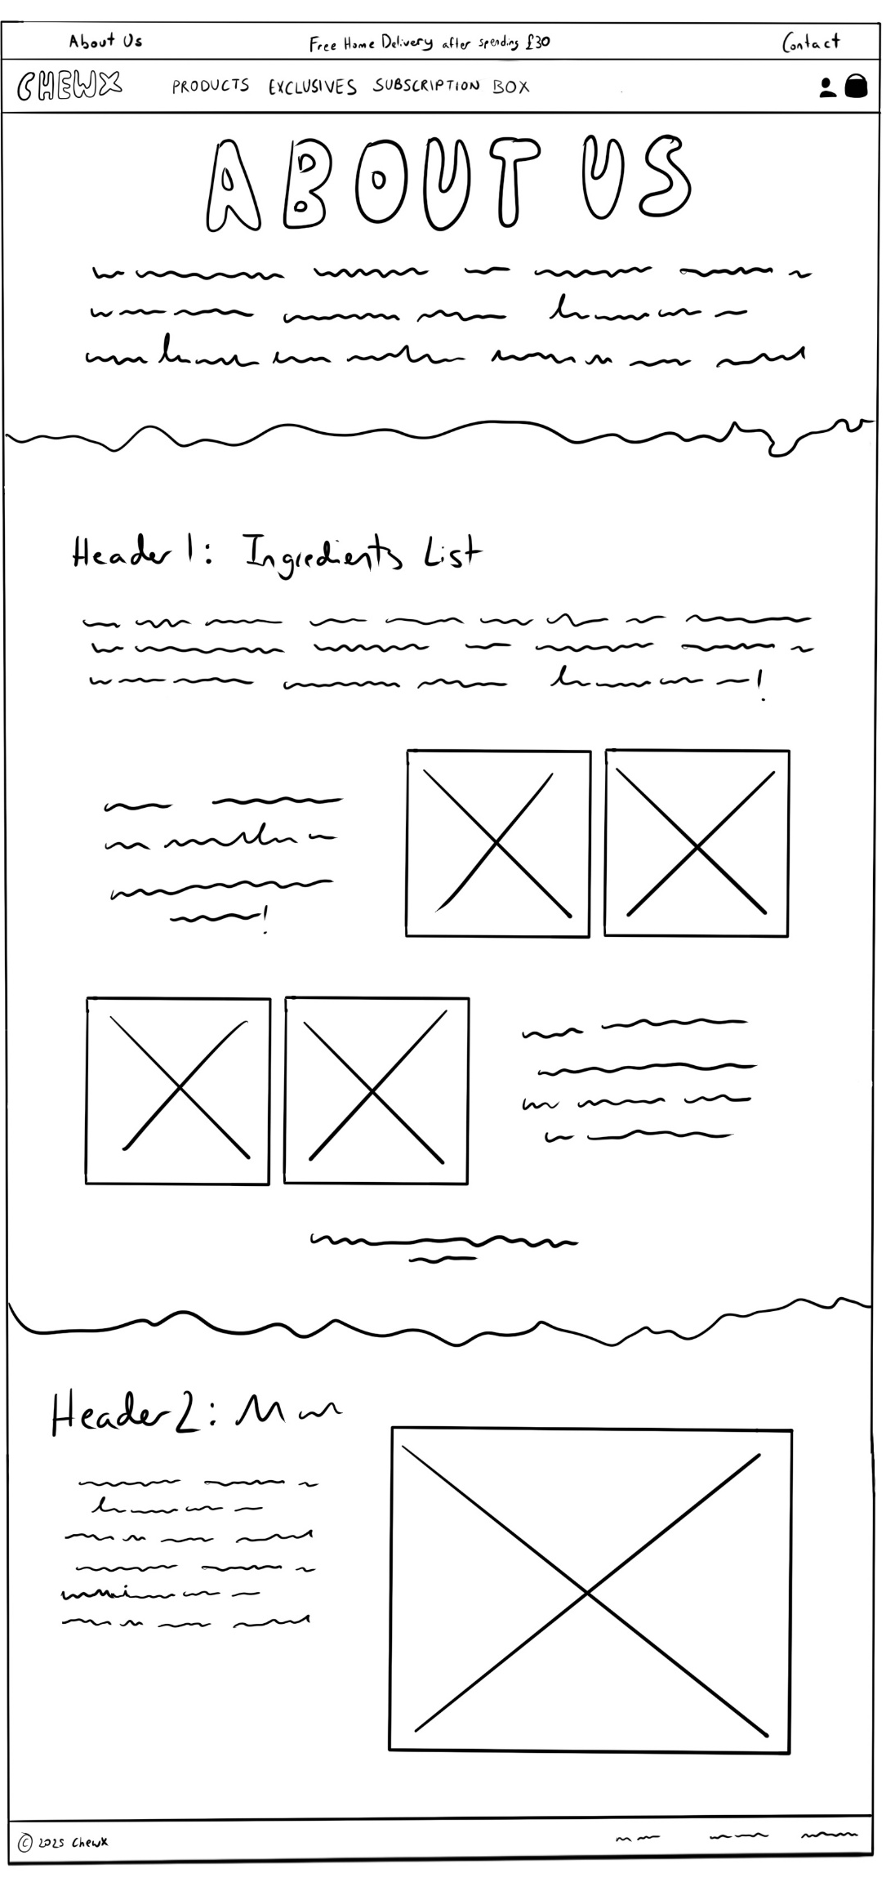
Low Fidelity – 2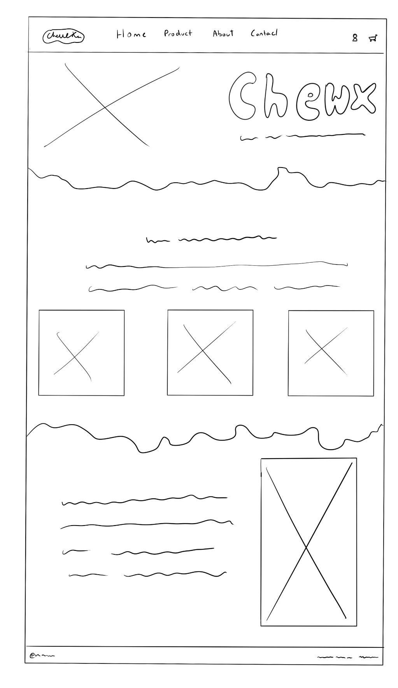
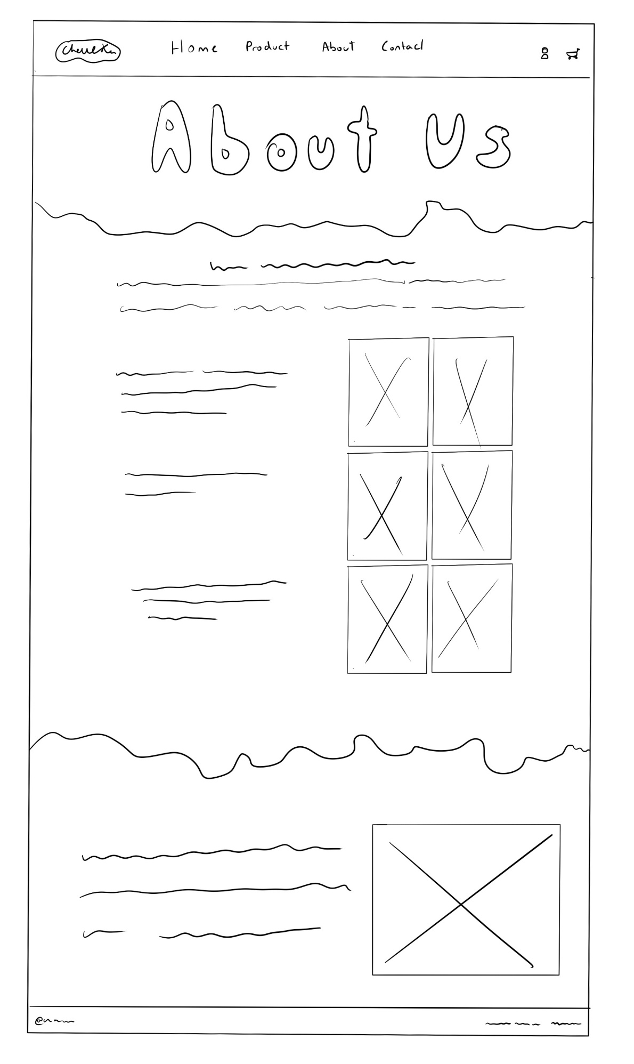
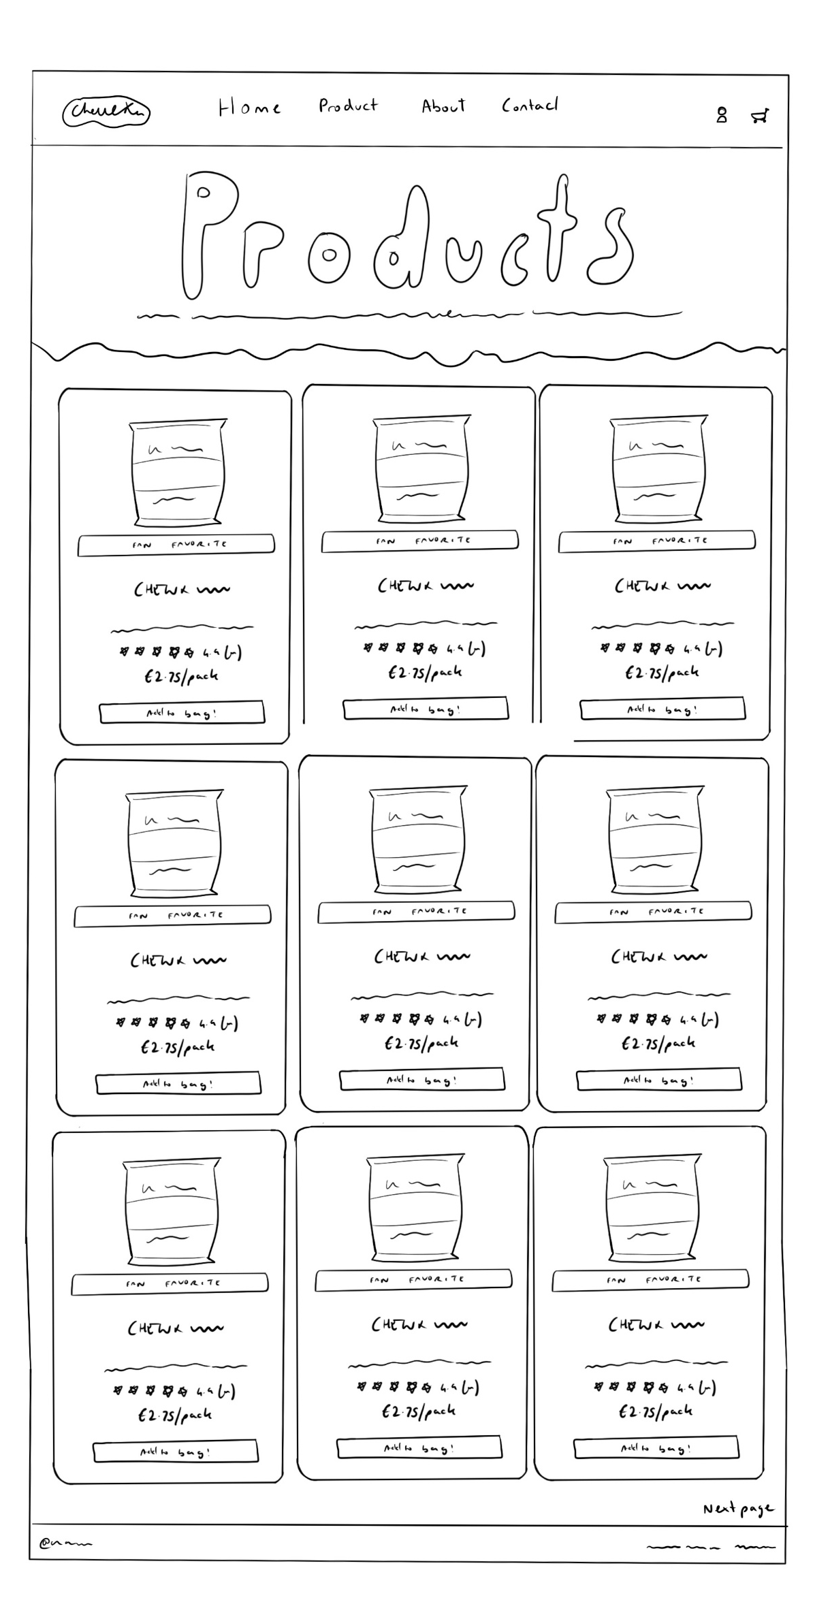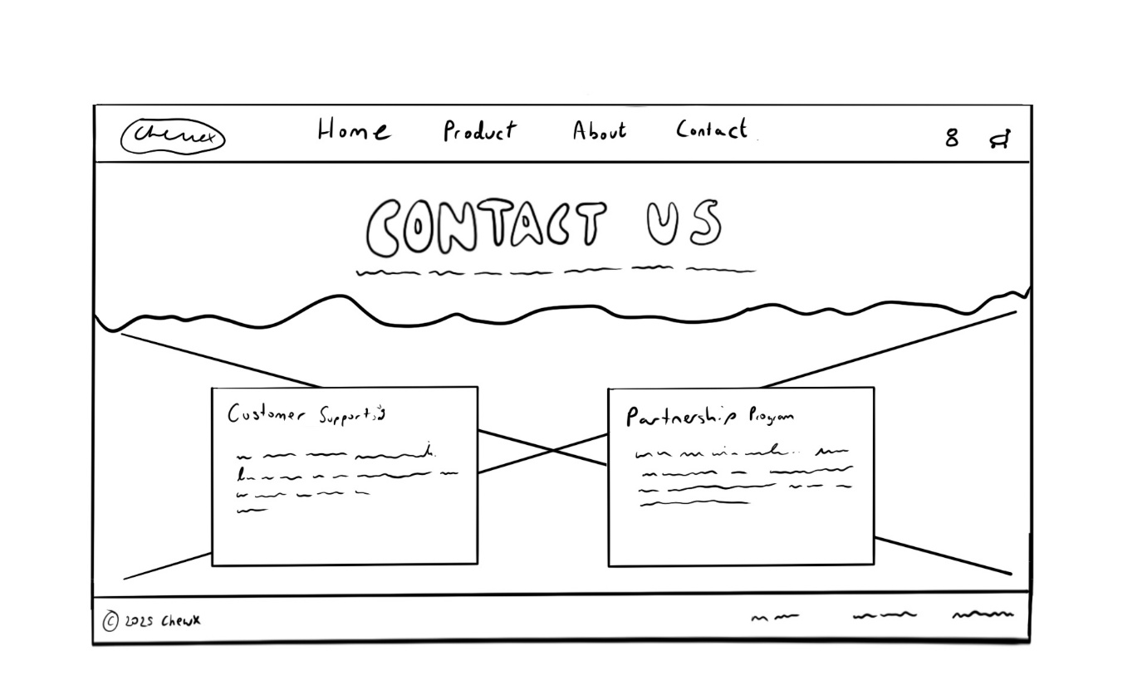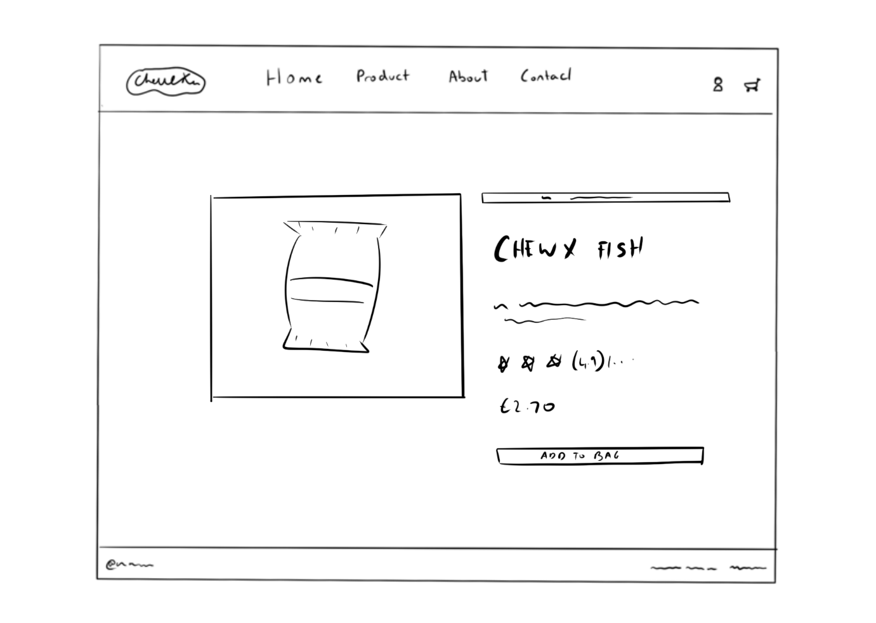

Medium Fidelity: 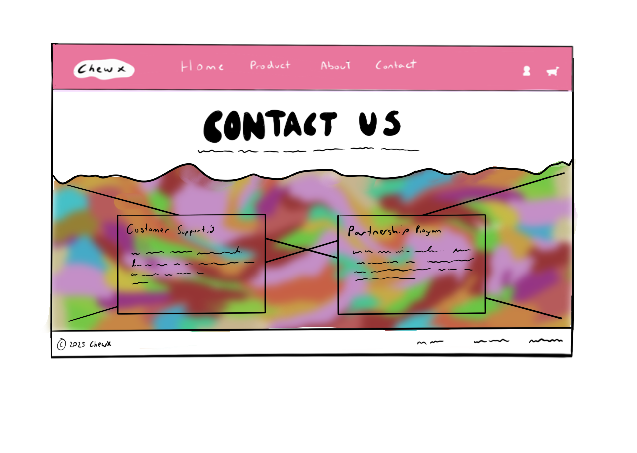
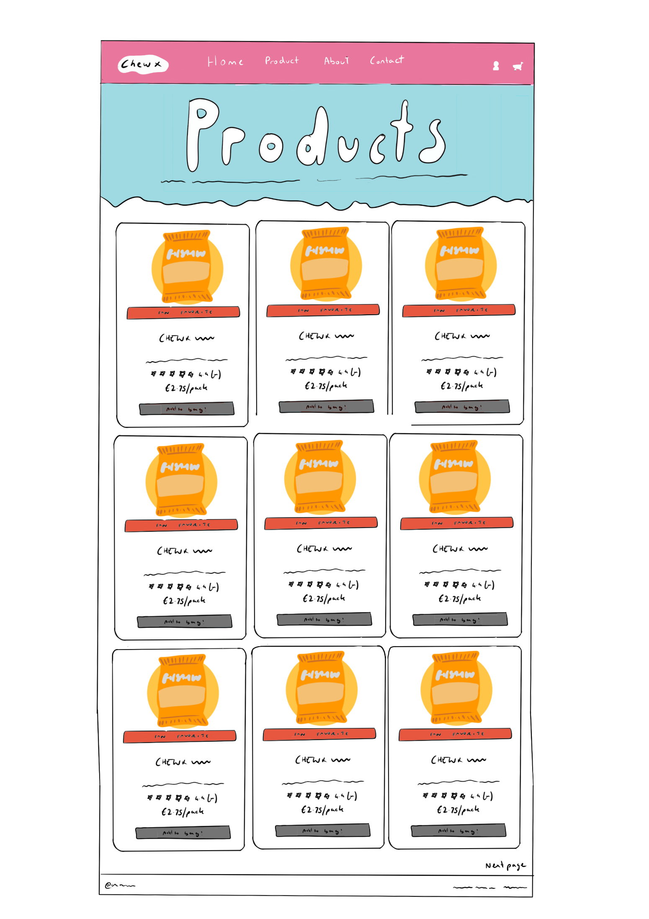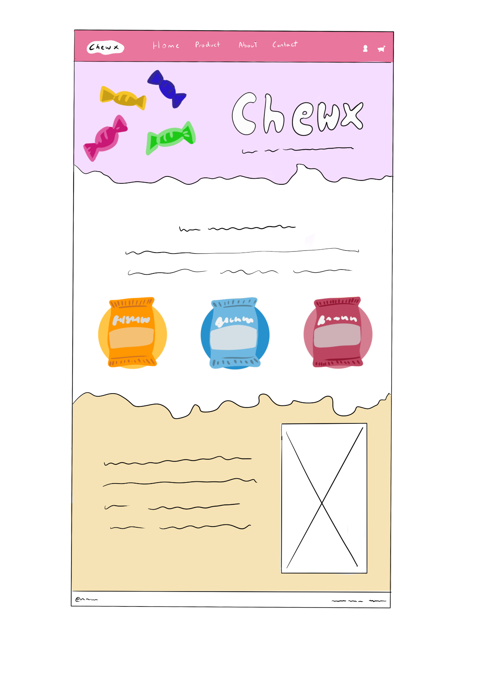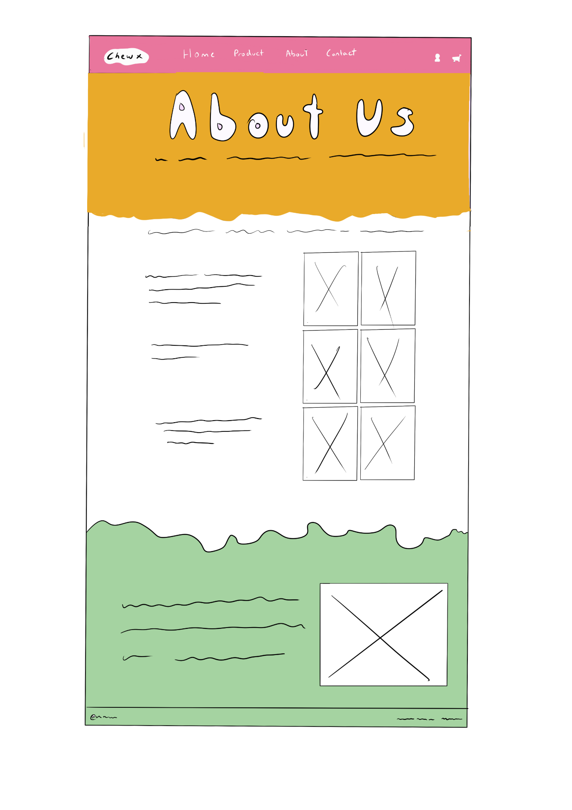

Site Map:


